Background:

* TASKING_License_Server_Windows_v1.4r3
* The server PC runs Windows Server 2012R2
* Tasking V6.2.1

**Install the local server**

1. The server PC was connected to the Internet.
2. The server PC port 8936 and 9090 are availible，but 8080 is not available.
3. Set the server PC IP address was 172.28.0.4
4. Install the TASKING_License_Server_Windows_v1.4r3 at C:\Tasking\ （位置不能变）
5. Creat licdfile.txt manually, and copy the relevant content to the file.（邮件里面有）

SW16080005062000=48lOGIWfMHlorWr9PAvXz94/8QpUmMy2B

ybHK+LX6ao1/+yD4W7FifJW0zXS8LXQ+KTY8uwtxgUcgaLLaSF

gpYDJ/cptspby3Ab7lDaScLAhqgo2uY3UVNyQI6KiL3wfpcxKr

6R1ylneOrEADsFaDQ7aFhhwzygsqkjClVkkKld0WPBWrpiI6Bu

3zR44nkqhv1BJRDnbjn+lX3d5ZrCVxx4ZlZsB4vvKCh8jx9AK8

abyDadOkOx1JtiKeD7lDNoWsy2D0nAlsME0kdJq4w==

1. Creat licdopt.txt， input the following：

# LicD license key for computer system with Security ID: jaAM-avFg-+2s9-mcDi

LICD_KEY=iPttgTIrGZzNX5+IoU4RIXF5Bdfdlq19E2U8Z8HQvL0XuPOfJYO8mxZ2ahObRO0bV8V3Cwtmu35qwEjTet5spF5ChLHvAsQ8WUgI7v3W3JGe59Ws7x07Ow==

LICD_LICFILE = licdfile.txt

LICD_LOGFILE = mylog.log

LICD_REM_SERVER=lic3.tasking.com:8936

LICD_LISTEN_PORT = 9090

LICD_AUTOREFRESH_TIMER = 100

1. Put licdfile.txt and licdopt.txt into C:\TASKING\

The local license server requires the license files to be in C:\Tasking

like

C:\Tasking\licdfile.txt

C:\Tasking\licdopt.txt

1. Using CMD based administrator account

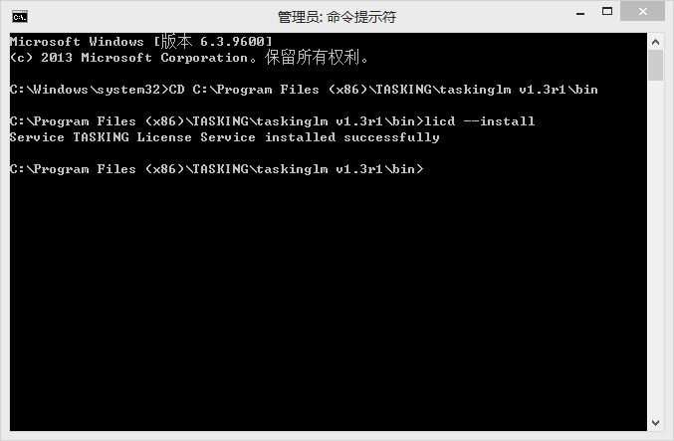

Input Licd --install

1. Input sc start “TASKING License Service**”. The information shows successfully started**

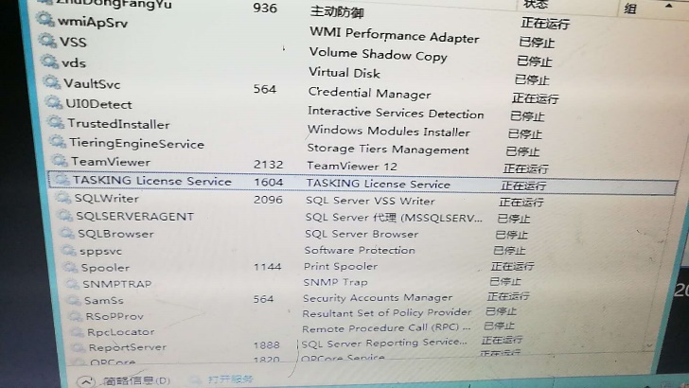

**以上是安装服务器的server**

1. **Install the client**
2. Input licence key，choose “local tasking licence server”

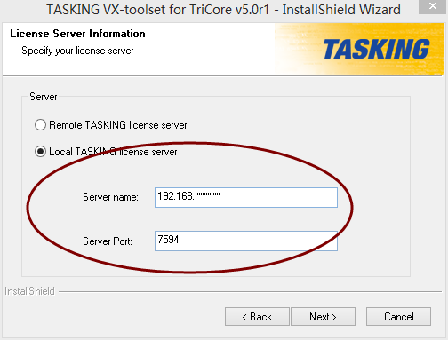

IP address was 172.28.0.4 with port 9090. 与服务器的IP 一致

1. Creat a new enviroment variables 创建环境变量，数值是tasking的安装路径\ETC\licopt.txt

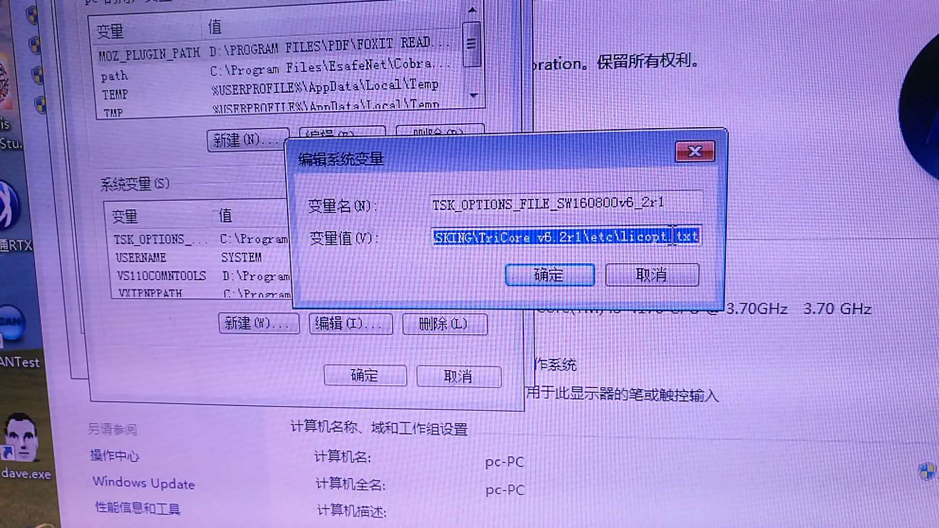

1. After installation,the licdopt file of the client shows： 查看安装后的OPT文件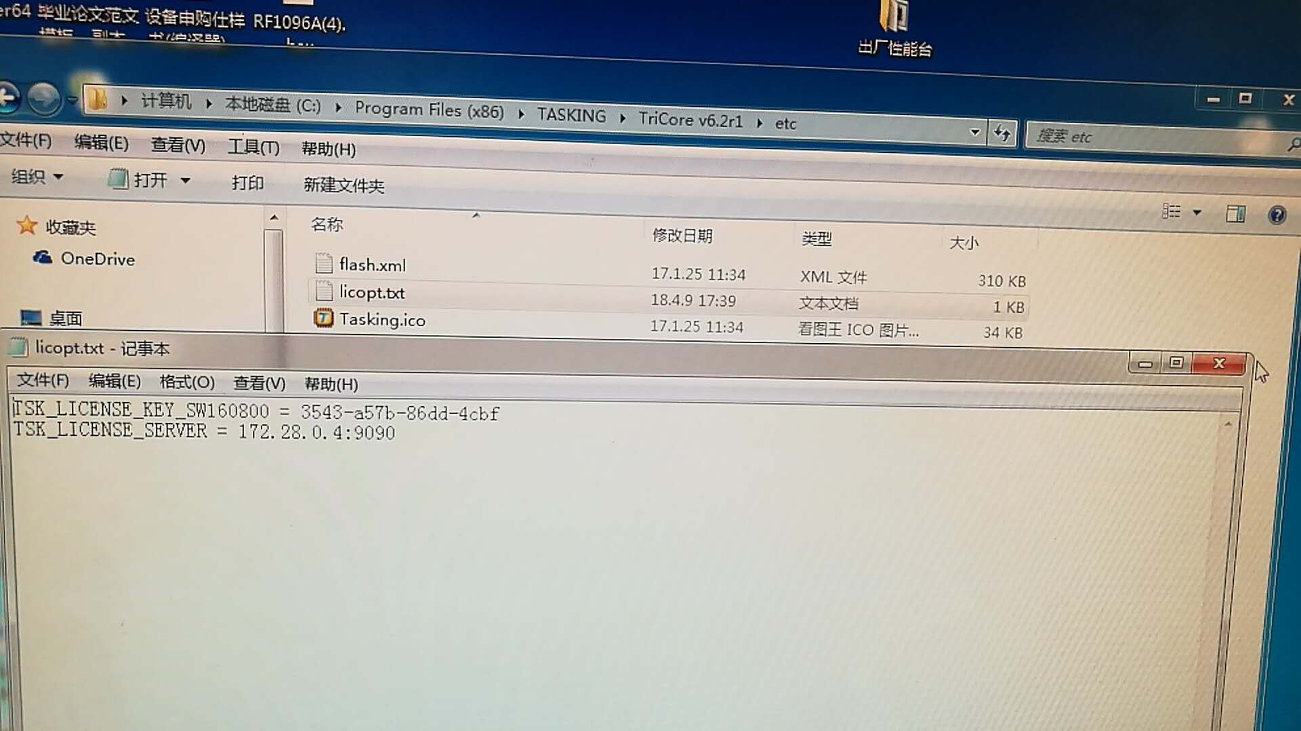
2. The client PC IP was 172.28.1.87

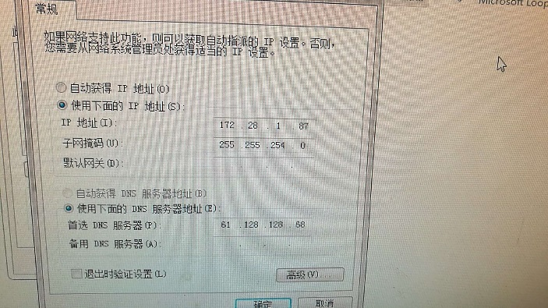

1. The network between the client PC and the server PC was OK.

